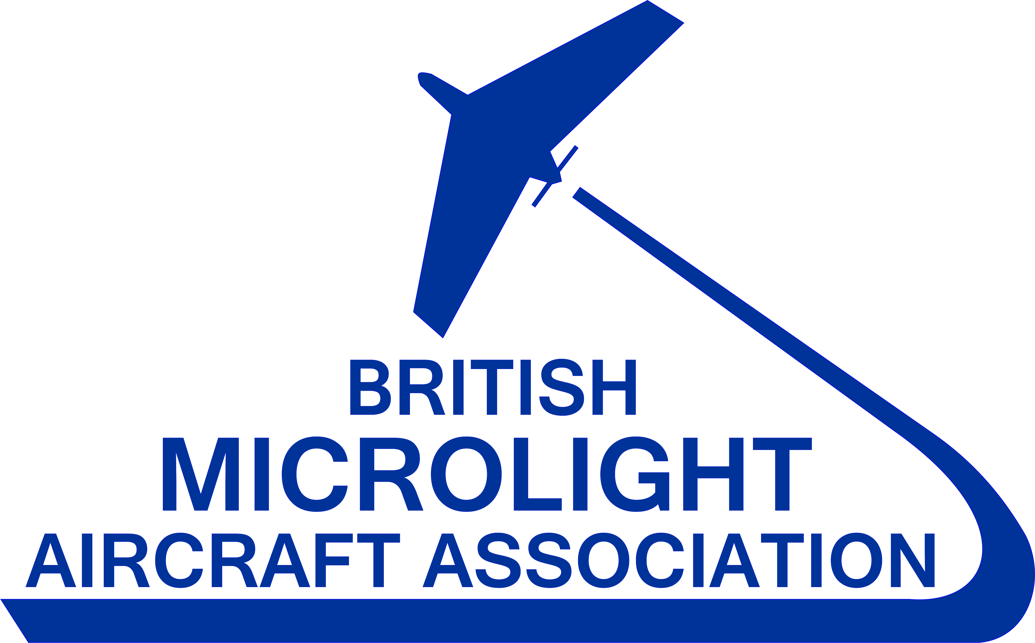

BMAA AGM 2018

Chief Executive’s Report to Members

Introduction
For several years I have produced an Annual Report with contributions from members of the BMAA Council, members of staff, the Editor of our magazine and sometimes contributions from other interest groups. As the 2018 AGM follows the 2017 AGM so closely, and is only partly through our financial year, that format is not appropriate at this time and so this report is different, being a summary of activity since last year written from my point of view as the Chief Executive.

BMAA - the background
When the BMAA was formed it took on the remit of representing the interests of a new group of pilots who flew what were mostly at the time powered hang gliders, with some odd-looking contraptions from far afield like the Eagle and Pterodactyl. No other organisation wanted to be associated with the “nutcases” flying these contraptions and pressure from the CAA for some sort of regulation was growing. The BMAA was formed and the “nutcases” had a voice. Ever since that time, almost 40 years ago, the BMAA Council members, along with volunteers and the BMAA employed staff, have continued to represent the interests of the BMAA members following the original remit. Keep microlight flying as simple and as cost effective as possible.

Regulation
The two main areas which attracted regulatory oversight were pilot training and airworthiness.

Pilot Training
Some may remember when the BMAA issued pilot certificates of competence. A basic certificate for local flying and an advanced certificate for cross country flying. In 1983 the CAA decided that microlight pilots should have CAA licences and, after initially imposing requirements similar to the light aircraft licence, were persuaded by the BMAA Training Committee to adopt a more suitable syllabus tailored to the type of aircraft that was being flown by microlight pilots.
Microlights have changed over the last 40 years. Faster, better handling, longer flight duration, more instrumentation, more comfortable to fly etc. The changes have prompted a review of the current training syllabus. The review has taken several years but is now close to completion. The interesting point is that despite the significant changes to the microlight fleet the syllabus is largely unchanged by the review. This does not mean that the review was not needed but demonstrates just how well the syllabus was written in the first instance.
There will be some changes to the emphasis within the text to highlight areas which, with a better understanding, may improve safety and reduce accident rates. For example, there are too many instances of aircraft overrunning a runway because the pilot set up the approach poorly. The emphasis on decision making has been highlighted in the new syllabus. Airspace infringements are a continuing problem in all aircraft types. In the navigation section the benefit of GPS enabled devices is now recognised and their proper use encouraged. An alternative qualifying cross-country flight is also included which is more appropriate to modern aircraft and how they are actually used.
The syllabus review has been conducted by the BMAA Training Committee. The committee is made up of volunteers working on behalf of the members. The review has been led by Fiona Luckhurst whose efforts on this project must be recognised and applauded.
Since the last AGM the Training Committee has also successfully run an Instructor Seminar for the microlight instructors and is currently undertaking a review of the NPPL examinations. The Microlight Panel of Examiners has met in 2018 and will be proposing some changes to the way that microlight flight examiners are appointed to achieve a more practical, skill-based, appointment that will be beneficial to new examiners.
In the field, over the first 7 months of the BMAA financial year microlight flight training has continued despite the poor weather and there have been 144 new licence applications and 8 applications to add a microlight rating to an existing licence. This is a little down on the same period last year, but not considered significant. The chart below shows the same 7-month period for the past 5 years for comparison.

Sub-70kg. In recognition of the common sense behind pilots taking training the BMAA is promoting the simple syllabus of the NPPL with operational limitations, and the existing instructor network, to pilots wishing to convert from hang gliding to flying the new breed of very light aircraft that fall into the sub-70kg class. There is no requirement for a licence to fly these aircraft, although they are effectively just light single seat microlights, but we consider training is sensible, even if not a legal requirement. The benefit of going through the training in this BMAA promoted way is the possibility of conversion to fly two seat microlights and heavier aircraft at a later date.

Airworthiness
The initial airworthiness of regulated microlights is controlled by the requirement to meet certain design and flight handling criteria. Ongoing airworthiness is the responsibility of the owner and is monitored by an independent inspection regime.
The BMAA provides an engineering service for members through the Technical Office. The three engineers who run the office all fly microlights and so appreciate what they are and how they are used. This experience allows them to bring a practical understanding to their role of approval and ongoing oversight.
Before airworthiness legislation was first introduced there were many more manufacturers of microlights than there are today. The requirement for manufacturer and design approval stopped some in their tracks and their designs ceased to exist. Although fewer manufacturers means less competition, and probably less innovation, the need for an improvement in the integrity of the aircraft was the driving force behind the regulation. The final straw in relaxed development was the in-flight failure of the Scorpion and Pathfinder Mk2 designs. Better to have design and manufacturing approval than unsafe aircraft.
Of course, in recent years the BMAA managed to persuade the CAA that for single seat aircraft the risk of structural failure was suffered only by the pilot and so all single seat microlights were removed from airworthiness regulation. This category of microlights, commonly referred to as SSDR, has a good safety record and is unlikely to come back into airworthiness regulation. The somewhat disappointing knock on effect of SSDR has been the resignation of membership of the BMAA by some owners who now they no longer need airworthiness services feel that the other benefits, and the support of the Association that took them out of regulation, is an unnecessary cost. A study conducted two years ago showed that the change in legislation that allowed some two-seat aircraft to be turned into single seat aircraft and be deregulated costs the BMAA in excess of £2,000 each year through lost membership fees alone.
Like the licensing function of the BMAA the Technical Office handles routine applications for members. The most obvious income that helps to fund the work that the Technical Office does comes from Permit revalidations. Income offsets costs such as staff salaries, building and equipment, and of course insurance. To protect the Association in the event of an error by staff or approved or appointed persons the BMAA carries several insurance policies. The cost of insurance for the technical roles is in excess of £36,500.
Since the 2017 AGM the Technical Office has completed the approval of two new types. The Breezer microlight and the Nynja light sport aircraft. They have also been kept busy with other routine applications. AANs (factory mods): 4, MAANs (mods and repairs): 9, HBs (homebuilt completions): 3, Minor Mods: 18, Standard Minor Mods: 49.
Routine Permit to Fly revalidations for the 7-month period of the financial year show continued decline. Weather is a factor in completing inspections and check flights, although the new check flying system has made the process less weather dependent and has generally been welcomed by owners.
The graphs below compare permit activity over the same period for the last 5 years and the general trend since 2008.

Flight Safety Promotion
Safety in aviation is paramount. Flying any aircraft has risks. The weak link in flight safety is generally accepted to be the pilot. Although as reported earlier we can have confidence in the microlight pilot training syllabus and its delivery by the instructors, humans are fallible. No one gets younger and lessons taught in training don’t always stay with you. Pilots need a continuous reminder of their own potential weaknesses and to be encouraged to do something to help maintain a good standard or improve on it.
In 2017 John Teesdale was appointed by the BMAA as a Flight Training Liaison and Safety Officer. His role is to be more active in flight safety promotion than we ever have been before. Just recognising recurring causes of accidents and hoping that pilots will get better is not good enough. John’s instructional experience in both fixed and flexwing microlights means that he can consider remedies and improvement programmes and put them into place. This is why the title includes Flight Training Liaison as well as Safety Officer.
To encourage pilots to improve their practical skills and knowledge the BMAA has almost completed ready for launch the BMAA Wings Scheme. Further-achievement schemes are not new in aviation, but other than the FAI Colibri scheme, essentially based upon competition type handling tasks, there is nothing available specifically for microlights. The BMAA Wings Scheme has several levels of achievement from Bronze to Diamond. Some of the steps to gain each award are flying based, each aiming to improve a pilot’s knowledge, planning and handling skills. One of the first flying courses to be developed concentrates on brushing up on landing strip skills in recognition of the number of incidents occurring when pilots visit unfamiliar fields. Other learning areas focus on non-flying achievements all with a safety theme. Examples are a visit to an active ATC unit or attendance at a GASCo or BMAA Safety event.


BMAA Courses
In recognition that most pilots actually want to know more the BMAA has begun to develop pilot courses. Recognition for development of the courses must go to BMAA Chief Inspector, Rob Mott. Rob started preparing engineering courses aimed mainly at Inspectors but has expanded his interest and developed other pilot courses. The emphasis of each course is always on giving benefit to the pilots who attend to help them become more knowledgeable about aviation.
First Aid for Pilots and Aviation Fire Courses are deliberately designed with aviation in mind. Flying Abroad and Radio courses are obviously beneficial to BMAA Members. These ground based courses all count for credit towards the BMAA Wings Scheme as well as being beneficial in their own right.

BMAA Membership
It is a fact that over the last few years membership of the BMAA has declined. The decline is not a plunge but a gentle slope. One reason already mentioned is the deregulation of all single seat microlights and the potential to change some two-seat aircraft to single-seat to become deregulated for airworthiness purposes. It is disappointing that microlight pilots would leave the organisation that has supported them apparently not giving any credit to the other work that the BMAA does on their behalf.
However, the BMAA cannot just accept that members will leave and shrug shoulders. All non-renewing members are contacted and invited to respond to a short survey so we can find out why they left. Sadly only a few respond to the survey. The majority of those that do have either given up flying or moved to a different class of aircraft.
Other surveys are carried out when new members join, after a membership has run 6 months and at membership renewal. All responses are considered and reported to the Council. Reports have been on an annual basis until this year. Now they are on a quarterly basis.
The surveys ask what is important to each member:

Likes and dislikes are recorded and attention is paid to them.

All comments on publications are passed to the editorial team who review them. Technical or regulatory issues are reviewed by the Council and staff. Those responsible do take notice of feedback.

Promotion
One of the Objects of the BMAA is to promote microlight flying. Promotion has to be cost-effective. Anyone can spend many thousands of pounds on advertising and reap very little reward, or at least cost-effective reward. The BMAA does not have many thousands of pounds to spend on promotion but does consider how funds can be best spent. The simulator is a great attraction and will be used throughout this year at some county shows and flying events. To get the best out of these attendances we try to encourage flying schools to partner up with us so that members of the public can make arrangements on the spot to take a flight.

The new website was launched this year. The emphasis of the site has been changed. It is designed primarily to promote microlight flying and in addition have a background information source. Judging by the increasing number of flight vouchers sold through the website the new approach seems to be working. The new website is also proving popular with members who own aircraft and inspectors as it allows them to view their aircraft records held by the BMAA. It is likely that with the introduction of the new General Data Protection Regulation coming into force in May 2018 some of this information will have to be restricted.


There is also a new bright image being used to promote microlight flying. You will see it being used more and more on BMAA publications and goods.

We are using social media more to improve communications. We are still looking for an individual to coordinate our promotional activities, because at the moment they are rather uncoordinated. We are speaking with someone in the near future, so hope to get that place filled.

Regulations
At the beginning of this report I referred to the CAA imposing regulation on microlight pilot licensing and airworthiness. There are a lot more areas of regulation that impact on us specifically and all general recreational aviation of which we are part. At the moment we are actively involved in several regulatory discussions.
600kg. European regulation is soon to see a change that opens the door for National Authorities to redefine microlights within their State. The change has been on the horizon for about two years and we have been urging our National Authority, the UK CAA to consider making a change to the UK definition of a microlight, specifically with the aim of increasing payload. The primary benefit, particularly for three axis aircraft, is that they can be designed to carry more than a teaspoon of fuel when two people of average size are aboard. Sadly, the CAA are well behind all the other States in making any decision and so we are almost still at square one. However, a meeting is scheduled for early May to discuss and promote our ideas for changes. We hope we can influence a change.
Remunerated flight training in amateur built aircraft. For at least two years we have been asking the CAA to amend regulation to allow remunerated flight training in amateur built aircraft. That is, a school could use a kit-built aircraft to train pilots who are not owners and be paid for it. At the moment a person who owns, or part owns, such an aircraft can pay for training, but a non-owner cannot. The non-owner can be instructed in the aircraft but cannot pay for it. We believe that changing the regulation would have no safety implication but would help make flight training less expensive and therefore help promote microlight flying over other forms of recreational flying. I continue to hope that the CAA will see it our way soon.
Manufacturer oversight. Several years ago, the BMAA proposed to the CAA that we be approved to take on a role of overseeing microlight manufacturer approvals. The basis for this was to reduce costs, improve timeliness and hopefully offer a more aware approach with microlight experience. This is another request for regulation change that has stalled and is with the CAA.

Airspace and airfields
We need airfields to fly from and airspace to fly in. Without either one flying just doesn’t happen. Together with other members of the General Aviation Alliance (GAA) we have been considering and responding to airspace change proposals where they may unduly restrict access to airspace for our members. Recently the pressure for a more coordinated approach to the establishment and use of airspace has increased. In January 2017 an All Party Parliamentary Group for General Aviation was formed and now has membership of around 150 MPs. The APPG has working groups for both airspace and airfield matters. We are engaged closely with both groups and are active in participating with their work. The recent Airspace Change Proposals by Oxford and Brize Norton have been criticised by the APPG as being unsafe. Support for general aviation at this level is welcome and we are committed to being part of the driving force behind it.

Finance
There is no getting away from the fact that to run any representative organisation there are costs. Each year I review income and expenditure and with the Treasurer, Rob Grimwood, prepare a financial budget for the year. Historically we know what our expected expenditure will be and we then try to set income levels to cover the expenditure but not make a positive margin. We set out to break even. The BMAA has reserves in the bank at a level approved of by our auditors. We don’t need or want to increase the reserves which are just there to cover working costs in the event of a sudden loss of income.
The BMAA income follows a predicable pattern each year starting with a period where expenditure exceeds income followed by income catching up to hopefully break even. The slowly reducing membership affects income, although as we have only increased membership and airworthiness fees once in the last three years it is not a surprise to see that income has been falling behind expenditure. The plan to maintain reserves rather than grow them is deliberate.
The graphs below show the trends of income and expenditure and how this year is following the traditional pattern:

Summary
The day to day processing of licence applications and instructor and examiner information continues with a revised syllabus nearing completion.
The improved Technical Office systems combined with the new website make Permit processing faster than ever. Increasing responsibility in order to assist manufacturers, and addressing the 600kg option, is at a frustrating standstill waiting for the CAA to find time to progress.
We are making positive moves towards the goal of improving microlight pilots’ knowledge and skills to improve flight safety, and soon hope to have the Wings scheme fully running.
We are actively reviewing our promotion of microlight flying and BMAA membership.
We are fully engaged at top levels with airspace regulatory matters and airfield support.
Our financial position is as expected , living within our means and being careful with members’ money.

